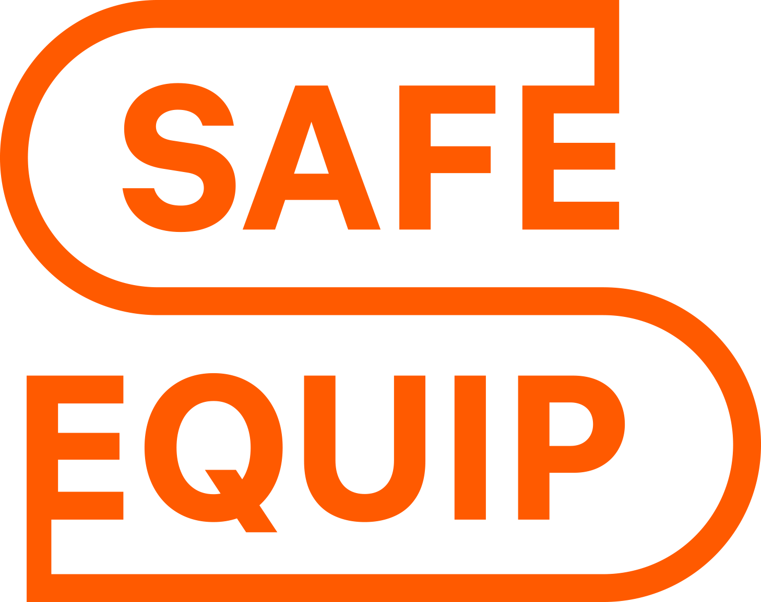 | 01 · EQUIPMENT PROPOSAL  SE-20260825-GN150-QA · V1  August 25, 2026

ON-SITE NITROGEN GENERATION  GN-150  Your nitrogen.  At your facility.  Complete station at 99.99% nitrogen purity.  AIR PREPARATION + PSA + STORAGE | 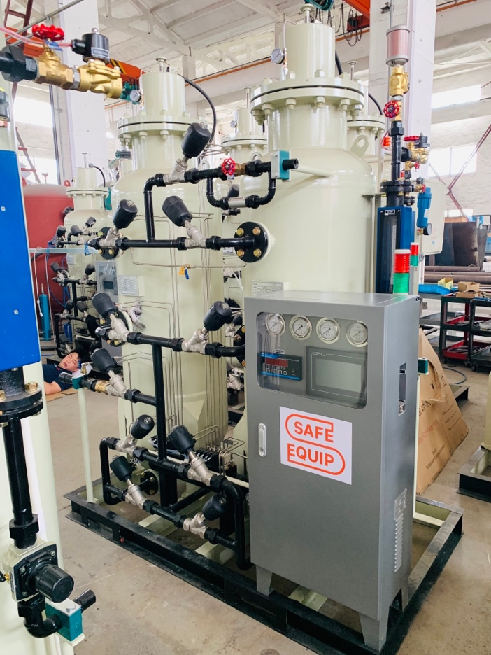  Safe Equip PSA equipment during factory assembly

99.99%  NITROGEN PURITY | 50 SCFM  CATALOG CAPACITY | Up to 100 psig  OUTLET PRESSURE

Prepared for Atlantic Advanced Manufacturing Solutions LLC
sales@s-equip.com · (727)349-5569
Complete station package | $146,650
Budgetary proposal · Through September 8, 2026 · next step: design confirmation review

02 · EXECUTIVE SUMMARY
Your project, on one page
The selected package, its operating point and the commercial basis.
Safe Equip proposes a GN-150 PSA nitrogen system based on verified commercial catalog performance at 99.99% nitrogen purity and 50 SCFM delivered capacity.
Your requirement  General industrial  Site utilities, operating hours and the demand profile are confirmed during the design review. | Our selection  GN-150 · 50 SCFM catalog output.  Up to 100 psig outlet pressure.  Ready for shipment: 9 weeks from order
WHAT’S INCLUDED
1 × Air compressor (KRSD-100); 1 × Air dryer (Safe Equip Refrigerated Air Dryer 500 CFM); 1 × Filters (CE-500-CTAH); 1 × Air tank (Vertical Air Tank 660 US gal); 1 × Nitrogen PSA generator (GN-150); 1 × Nitrogen process tank (Vertical Air Tank 240 US gal); 1 × Nitrogen buffer tank (Vertical Air Tank 240 US gal).
Budgetary investment · tax excluded
$146,650
Equipment payments: $43,995 / $58,660 / $43,995 · Order / factory ready / before shipment

Next step — design confirmation review
Confirm site layout, utilities, point-of-use pressure and the project schedule before the final order.

03 · THE COMPLETE SOLUTION
Your nitrogen system
Every included component is visible; exclusions are made explicit before order.
Complete nitrogen station · all primary process-train components included.
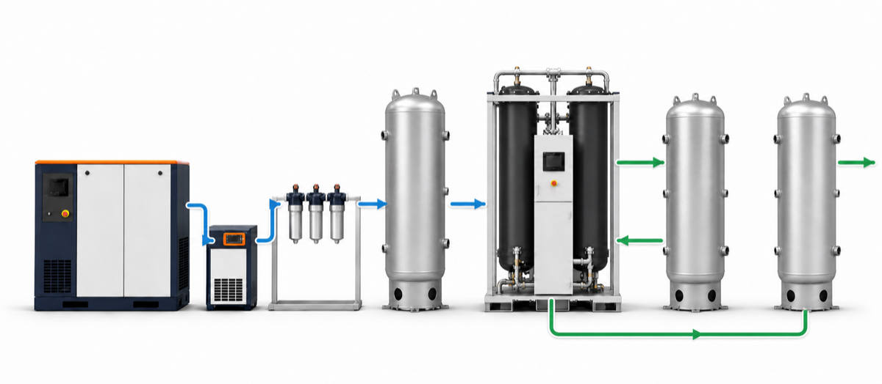
01  Air compressor | 02  Air dryer | 03  Filters | 04  Air tank | 05  PSA nitrogen generator | 06  Nitrogen process tank | 07  Nitrogen buffer tank

Scope boundary is visible before purchase
Gray equipment remains visible to preserve the process context when it is not included. Final battery limits, customer connections, and optional services are frozen during the Design Confirmation Review.
Air preparation  The compressor, dryer, filters and air tank prepare the compressed-air feed required by the PSA. | Generation and storage  The process tank supports analysis of generated nitrogen. The separate buffer tank stores qualified nitrogen for the customer.

04 · OPERATING POINT
A defined operating point
Catalog values are separated from contractual guarantees and tied to explicit test conditions.
Generator model | GN-150
Selected nitrogen purity | 99.99%
Nitrogen capacity | 50 SCFM
Requested nitrogen flow | 50 SCFM
Required compressed air | 224 SCFM
Nitrogen outlet pressure | Up to 100 psig
Required inlet-air quality | ISO 8573-1:2010 Class 1.4.1
Our selection
Ready for shipment: 9 weeks from order
PERFORMANCE BY NITROGEN PURITY
Purity | 99% | 99.5% | 99.9% | 99.95%
N2 flow, SCFM | 124 | 93 | 62 | 56
Air feed, SCFM | 274 | 233 | 193 | 213
Purity | 99.99% | 99.995% | 99.999%
N2 flow, SCFM | 50 | 34 | 31
Air feed, SCFM | 224 | 163 | 187
Air-flow values remain in SCFM even when nitrogen capacity is displayed in SCFH.
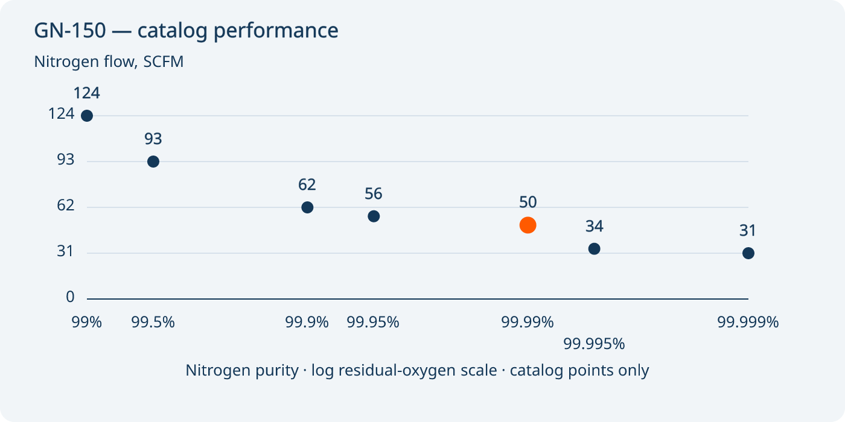
GN-150 · exact catalog points from this snapshot; no interpolation or site performance guarantee.

05 · AIR BALANCE
Air capacity, from inlet to PSA
Catalog air capacities and the PSA air-feed requirement are kept separate.
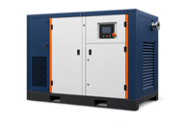  Air compressor  412 SCFM  KRSD-100 | 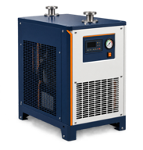  Air dryer  500 SCFM  Safe Equip Refrigerated Air Dryer 500 CFM | 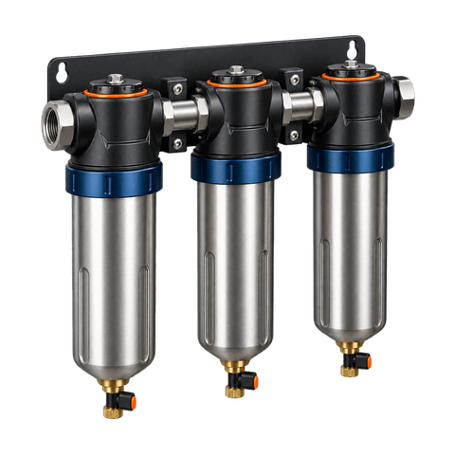  Filters  500 SCFM  CE-500-CTAH | 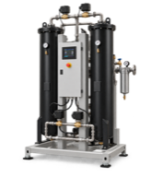  PSA feed  224 SCFM  GN-150

Generator inlet-air basis
ISO 8573-1:2010 Class 1.4.1
Confirm available air flow, pressure and air quality at the site. Catalog capacities are compared at their stated conditions; this comparison is not a system performance guarantee.

06 · AIR-SIDE EQUIPMENT
Prepared air, matched equipment
The included air equipment and its verified specifications.
INCLUDED · QTY 1  Air compressor  KRSD-100  Compressor capacity: 412 SCFM  Why this unit: Supplies the compressed-air feed for the PSA process. | INCLUDED · QTY 1  Air dryer  Safe Equip Refrigerated Air Dryer 500 CFM  Rated air flow: 500 SCFM  Why this unit: Removes moisture before the downstream filters and generator.

INCLUDED · QTY 1  Filters  CE-500-CTAH  Rated air flow: 500 SCFM  Why this unit: Treats particles, oil aerosol and other contaminants before the PSA generator. | INCLUDED · QTY 1  Air tank  Vertical Air Tank 660 US gal  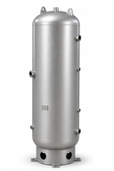  Vessel capacity: 660 US gal  Why this unit: Provides compressed-air storage between the air supply and PSA generator.

07 · NITROGEN-SIDE EQUIPMENT
The heart of your nitrogen system
The selected generator and the nitrogen tanks included in this package.
INCLUDED · QTY 1
GN-150
Nitrogen PSA generator
Dew point -60°F · Ambient 40°F to 95°F · Air in G2" · N2 out G1½"
Nitrogen capacity at 99.99%: 50 SCFM
Why this unit: Separates nitrogen from prepared air at the selected catalog operating point.

INCLUDED · QTY 1  Nitrogen process tank  Vertical Air Tank 240 US gal  Vessel capacity: 240 US gal  Why this unit: Receives generated nitrogen while the analysis instruments verify its quality. | INCLUDED · QTY 1  Nitrogen buffer tank  Vertical Air Tank 240 US gal  Vessel capacity: 240 US gal  Why this unit: Stores qualified nitrogen and smooths downstream demand.

08 · SUPPLY BOUNDARIES
What’s included. Who does what.
Equipment supply and site installation each have a clear owner.
Safe Equip supplies  The equipment in the included Bill of Materials.  Delivery is excluded unless expressly included in the commercial scope.  Installation supervision and commissioning are excluded unless expressly included in the commercial scope.  The equipment documentation listed in this quote’s document register.  Warranty: 12 months for supplied equipment. | Customer or local contractor  Site access and unloading.  Foundations, supports and local civil works.  Interconnecting process pipework and electrical installation.  Utilities, local permits and approvals.  Connection to the plant nitrogen distribution system.

09 · DESIGN CONFIRMATION
Turn the selection into your project
A short confirmation review prevents hidden changes to equipment, price, footprint, and schedule.
Review item | What will be confirmed | Status
Outlet pressure | Up to 100 psig | Defined in the agreed acceptance plan
Inlet-air quality | ISO 8573-1:2010 Class 1.4.1 | Defined in the agreed acceptance plan
CUSTOMER INPUTS
- Confirm site utilities and available electrical service.
- Confirm the normal, peak, and future nitrogen demand profile.
- Confirm installation location, ambient conditions, and tie-in requirements.
REVIEW OUTCOME
- Confirmed design basis and equipment interfaces.
- Approved equipment schedule and project-specific submittal list.
- Formal commercial quotation with the final scope and execution terms.
Current status
Budgetary selection · engineering confirmation required before order release.

09B · ACCEPTANCE
Verify performance before handover
The draft acceptance framework converts the proposal into measurable pass criteria.
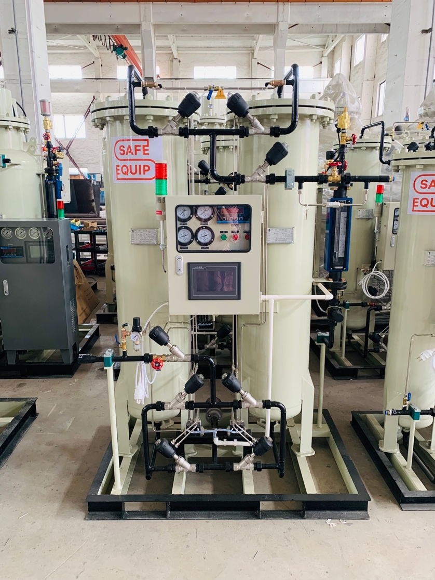  PSA equipment during factory assembly and inspection | Valve train, instruments, and control panel before shipment
PROPOSED ACCEPTANCE FRAMEWORK
Review item | What will be confirmed | Status
Performance basis | Purity, flow, pressure, and inlet-air conditions documented against the approved design basis. | Defined in the agreed acceptance plan
Factory verification | Project-specific inspection and test protocol defined in the approved submittal package. | Included after order
Release record | Applicable drawings, manuals, and test evidence compiled before shipment release. | Included after order

Measured under agreed conditions
The approved acceptance plan defines purity, flow, pressure, stabilization time, inlet-air quality, test duration, instruments, and witness requirements.

10 · WORKING TOGETHER
From first review to production
The project succeeds when equipment, site work, approvals, and acceptance are owned by name.
DELIVERY PATH
Week 0 — order confirmed
Week 9 — ready for shipment
01 | Order confirmation · Order confirmed  Agree the selected equipment package and project scope.  Equipment payment: $43,995

02 | Project submittals · Before production  Issue equipment data sheets, drawings and interfaces for review.

03 | Build and factory verification · Before shipment  Complete assembly and the agreed factory checks.  Equipment payment: $58,660

04 | Shipment release · Week 9 · ready for shipment  Complete shipment documentation and coordinate delivery.  Equipment payment: $43,995

05 | Startup and handover · After installation  Commissioning and operator orientation when selected.

Workstream | Safe Equip | Customer / others
Design basis | Prepare the equipment selection and project submittal. | Confirm duty, utilities, site conditions, and interfaces.
Site readiness | Provide equipment interface information after order. | Prepare foundations, utilities, piping, access, and permits.
Startup support | Provide supervision and operator orientation when selected. | Provide safe access, utilities, operators, and site support.
SELECTED PROJECT SERVICES
- Delivery and installation supervision / commissioning are optional unless expressly included in the line-item schedule.

11 · SUPPORT AND REFERENCES
Support beyond delivery
Documentation, service boundaries, and spares are defined instead of being implied.
DOCUMENT REGISTER
Document | Status
Approved equipment data sheets | Included after order
General arrangement and connection information | Included after order
Operation and maintenance manuals | Included after order
Project-specific test record | Defined in the agreed acceptance plan
SUPPORT OPTIONS
Preventive-maintenance plan · Optional
Recommended service intervals and consumables can be supplied for the approved package.
Recommended spare parts · Optional
A project-specific startup and operating-spares package can be added.
Operator orientation · Optional
Operating and routine-care training can be included with startup support.

11B · EVIDENCE
Visible equipment. Verifiable references.
No unverified savings or uptime claims are used in this proposal.
Safe Equip develops nitrogen generation packages around verified performance data, application requirements, and a clearly documented equipment train. Engineering and commercial coordination are managed from Clearwater, Florida, with system assembly and factory verification performed under the approved project specification.
APPROVED REFERENCE SYSTEMS
Genista | Laboratory and industrial use · 19 SCFM
MacroCap Labs | Controlled-atmosphere production · 155 SCFM
Beta Diagnostic Labs | Laboratory nitrogen supply
Safe Equip PSA equipment during factory assembly

12 · OPERATING COST
Your operating cost, made clear
A customer-specific comparison after the operating inputs are confirmed.
Customer-specific operating-cost review
Safe Equip can compare onsite nitrogen generation with the customer’s delivered-gas baseline after the operating and utility inputs are confirmed.
Inputs required | Review deliverables
Electricity rate  Annual operating hours  Delivered-gas price and fees  Peak and average nitrogen demand | Estimated annual electricity use  Onsite-generation cost basis  Delivered-gas comparison  Simple payback range after inputs are confirmed
Status · Optional · prepared after customer inputs are confirmed

12B · YOUR MODEL — QUESTIONS ANSWERED
Useful details, ready for your team
Specifications for the selected generator.
When is the equipment ready to ship?
Ready for shipment: 9 weeks from order. 60 days ex-works.
What are the generator connections?
Air in G2" · N2 out G1½"
What is the nitrogen dew point?
-60°F
What ambient temperature range applies?
40°F to 95°F
What is the generator connected load?
0.2 kW

13 · INVESTMENT AND TERMS
Everything in your package
The formal order-ready proposal is issued after the Design Confirmation Review.
 | Commercial scope | Qty | Line total
 | Air compressor  KRSD-100 | 1 | $36,800
 | Air dryer  Safe Equip Refrigerated Air Dryer 500 CFM | 1 | $8,750
 | Filters  CE-500-CTAH | 1 | $3,400
 | Air tank  Vertical Air Tank 660 US gal | 1 | $11,900
 | Nitrogen PSA generator  GN-150 | 1 | $79,000
 | Nitrogen process tank  Vertical Air Tank 240 US gal | 1 | $3,400
 | Nitrogen buffer tank  Vertical Air Tank 240 US gal | 1 | $3,400
 | Budgetary total (tax excluded) |  | $146,650
COMMERCIAL TERMS
Payment | Equipment: 30% deposit due upon receipt of order; 40% due upon notification that the equipment is ready at the factory; final 30% due prior to shipment. Startup, commissioning, and training: Net 30 (payment due within 30 days of the invoice date).
Lead time | 60 days ex-works
Warranty | 12 months for supplied equipment
Offer validity | Through September 8, 2026
Currency / tax | USD; sales and use taxes are excluded
Commissioning | Quoted separately unless expressly included in the commercial scope
Your package: $146,650 · Through September 8, 2026  1. Review the equipment package · 2. Confirm site and delivery details · 3. Approve the final order  Final equipment selection requires Safe Equip engineering confirmation before purchase.  sales@s-equip.com · (727)349-5569 | 

A1 · NITROGEN GENERATION
How your nitrogen system works
Compressed air is dried and filtered before the PSA generator separates nitrogen. The diagram shows the gas path and the instruments that monitor its quality before delivery to your process.
01  Air compressor | 02  Air dryer | 03  Filters | 04  Air tank | 05  PSA nitrogen generator | 06  Nitrogen process tank | 07  Nitrogen buffer tank
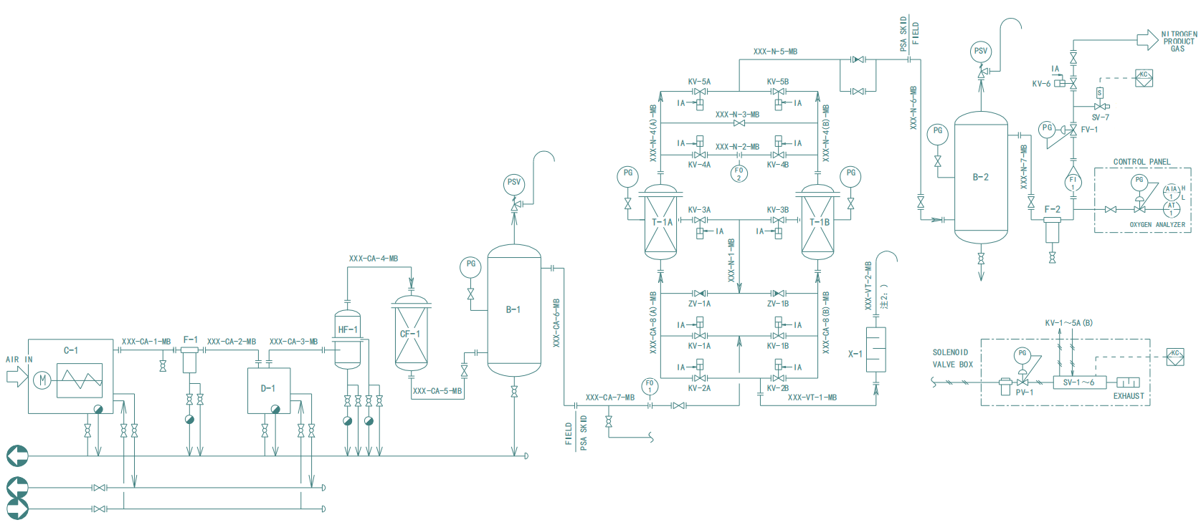
Concept diagram only. Exact model and revision drawings are not confirmed. Approved project drawings govern fabrication and installation.
Why the two nitrogen tanks matter
Generated nitrogen first enters a dedicated process tank. Gas is then routed through the generator analysis section for continuous measurement by the gas analyzer, flowmeter, and electronic pressure instrumentation before entering the separate nitrogen buffer tank and the customer distribution system.
The separate buffer tank stores qualified nitrogen and helps smooth pressure and flow as your demand changes.
1 · Air preparation  Compressor, dryer and filters condition the feed. | 2 · Separation and control  PSA vessels, valves and instruments govern generation. | 3 · Product and monitoring  The process tank and analyzer support product monitoring.

A2 · GLOSSARY
The technical terms, in plain English
A short guide for purchasing, engineering and operations.
SCFM / SCFH  Standard cubic feet per minute / per hour. Nitrogen can be displayed in either unit; compressed-air values remain in SCFM. One SCFM equals 60 SCFH. | PSA  Pressure Swing Adsorption: the generator separates nitrogen from compressed air using alternating adsorption vessels.

PDP  Pressure dew point: the temperature at which moisture condenses at the stated gas pressure. A value is shown only when confirmed for the selected model. | ISO 8573-1 air quality  The three class numbers describe particles, water and oil in that order. The specified inlet-air quality is part of the design basis.

Purity and flow  The generator catalog lists a nitrogen flow and an air-feed requirement for each purity. These discrete points do not guarantee intermediate or site-specific performance. | Process tank / buffer tank  The nitrogen process tank receives gas during analysis. The separate buffer tank stores qualified nitrogen for the customer distribution system.

